New Lead CRM & Follow Up Automation
Zapier | Typeform | GoHighLevel | Google Sheets | Gmail | Twilio | Slack | Asana

Project Overview
Built an automated lead management workflow that captures new form submissions, checks lead status, updates the CRM, notifies the team, and manages follow up communication.
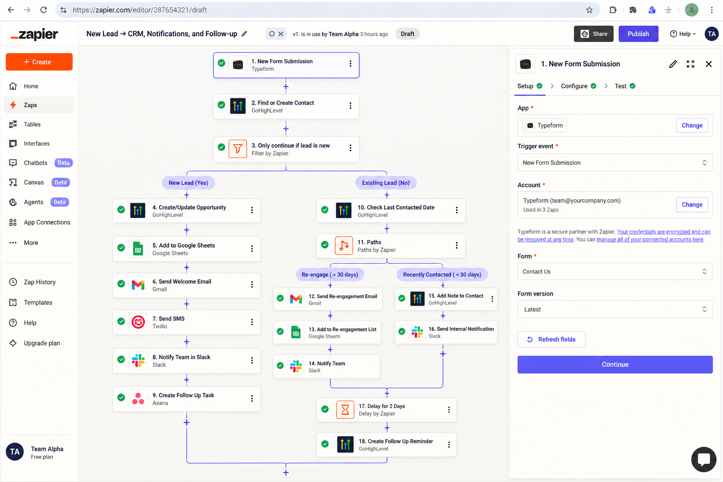

New Lead Workflow
For new leads, the system:
• Captures the Typeform submission
• Finds or creates the contact in GoHighLevel
• Checks whether the lead is new
• Creates or updates the opportunity
• Adds the lead to Google Sheets
• Sends a welcome email
• Sends an SMS
• Notifies the team in Slack
• Creates a follow up task in Asana

Existing Lead Workflow
For existing leads, the system checks the last contact date and routes the lead based on the result.

Re Engage
If the lead has not been contacted for more than 30 days:
• Sends a re engagement email
• Adds the lead to a re engagement list
• Notifies the team in Slack

Recently Contacted
If the lead was contacted within 30 days:
• Adds a note to the GoHighLevel contact
• Sends an internal Slack notification

Follow Up
After the lead is processed:
• Waits 2 days
• Creates a follow up reminder in GoHighLevel

Technology
• Zapier
• Typeform
• GoHighLevel
• Google Sheets
• Gmail
• Twilio
• Slack
• Asana

Result
An automated lead handling system that manages new and existing leads, keeps the CRM updated, notifies the team, and ensures follow ups are created without manual tracking.

